<Project Name>

To put in a client name select all (ctrl A) then f9Nash Tech Software Development

**Test Plan**

**Version – Issue 1.3**

**Thuy Vu, QC Lead**

**Sept, 2012**

13 Bruton Street

London

W1J 6QA

Tel: +44 (0)20 7333 0033

Fax: +44 (0)20 7333 0032

Email: [Tim.lewis@harveynash.com](mailto:Tim.lewis@harveynash.com)

RECORD OF CHANGE

* A – Added, M – Modified, D - Deleted

|  |  |  |  |  |
| --- | --- | --- | --- | --- |
| **Date** | **Changed Items** | **\*A, M, D** | **Description** | **Version** |
| Sept 11st, 2012 | Add new document. | A | First design of the Test Plan | 0.1 |
| Sept 13nd, 2012 | 1.5, 3.1, 3.3, 4, 5.3 | M | Review with PM | 1.1 |
| Sept 21st, 2012 | 1.3, 2.1, 2,3, 2.4, 3.2 5.3 | A, M | Review with QCM | 1.2 |
| Sept 24th, 2012 | 2.1, 3.2 | M | Review with QCM | 1.3 |
|  |  |  |  |  |
|  |  |  |  |  |
|  |  |  |  |  |
|  |  |  |  |  |
|  |  |  |  |  |

SIGN OFF

|  |  |  |  |
| --- | --- | --- | --- |
|  | Name & Role | Date | Signature |
| **Originator** | Thuy Vu, QC Lead | Sept 11st, 2012 | Thuy Vu |
| **Reviewer/s** | Nhan Nguyen, QCM  Khoa Duong, PM | Sept 13nd, 2012  Sept 21st, 2012 |  |
| **Approver/s** | Guy Pearce, Senior Business Analyst |  |  |

**CONFIDENTIALITY**

This document is distributed on a restricted basis, is commercial in confidence to the recipient, and may not be used for any purpose other than that associated with a Nash Tech project. The contents of this document may not be disclosed to any third parties without the expressed advance written authorisation of Nash Tech.

TABLE OF CONTENTS

1 Introduction 3

1.1 Purpose 3

1.2 Background information 3

1.3 Scope 3

1.4 Exclusions 3

1.5 Risk list 4

2 TEST STRATEGY – TESTING TECHNIQUES AND TYPES 4

2.1 Functional Testing and Non-Functional testing 4

2.2 User Interface Testing 5

2.3 Performance and Volumetric Data testing 5

2.4 Regression Testing 6

3 RESOURCES 7

3.1 Human Resources 7

3.2 Environment 8

3.3 Timeline 8

4 DELIVERABLES 8

5 SUSPENSION / EXIT CRITERIA 9

5.1 Suspension Criteria 9

5.2 Resumption Criteria 9

5.3 Exit Criteria 9

6 REFERENCES AND RELATED DOCUMENTS 11

# Introduction

## Purpose

This document describes the plan to implement and execute testing process for the <Project Name> project. It will be used by QC Engineers, BA, and PM.

This document contains the outline of the high level test plan for the <Project Name> project. It identifies:

* Requirements to be tested and not tested during the life cycle of <Project Name> application.
* Scope, resources and schedules of testing activities.
* Test strategies/methodologies/approaches to be tested during test life cycle.
* Pass/fail criteria and risk assessment.
* Lists of testing deliverables

## Background information

<Project Name> is the software to create the individual flat files containing all accounting journal entry (Debit or Credit) for each entity for a certain day. This application is also required to create a report of the process.

The process of transforming the single file into multiple smaller files for each entity may encounter issues and it is required for the software to allow manual intervention so that these erratic transactions can be correctly imported.

## Scope

The tests will be performed to verify that all requirements in the Use Cases meet users need. Refer to “<Project Name>_SRS v1.1” file for the list of Use Cases

* Function test and Non-function test
* Performance and Volumetric Data test
* GUI test
* Regression test

## Exclusions

* No migration involved
* No external libraries have been identified as needed so far. Recommending using ExtendJS library for which license will run around £1000
* No special requirements on an online help system.

## Risk list

In this project, there are some major risks as below:

* Project timescale too short with only 2 months development, testing and release to match with the RAS application release date. The time for testing is too short to cover the regression for all features.
* There might have some disagreements between development and test team point of view that causes time to finalize.
* The rules in lookup tables are very complicated that makes testing might miss cases.

# TEST STRATEGY – TESTING TECHNIQUES AND TYPES

The following strategy will be followed in this project:

* The test cases/checklist will be generated by QCs
* QCs will execute the test cases to make sure all functions work correctly in the full package.
* The Pass/Fail status of each test will be recorded. It will be called test result

## Functional Testing and Non-functional Testing

Function testing of the target-of-test should focus on any requirements for test that can be traced directly to use cases or business functions and business rules. The goals of these tests are to verify proper data acceptance, processing, and retrieval, and the appropriate implementation of the business rules. This type of testing is based upon black box technique; that is verifying the application and its internal processes by interacting with the application via the Graphical User Interface (GUI) and analyzing the output or results.

|  |  |
| --- | --- |
| **Test Objective** | Ensure proper target-of-test functionality, including navigation, data entry, processing, and retrieval. |
| **Technique** | - Create the test case to cover all use-case workflow, business rules.  - The boundary testing technique using to verify the following:   * The expected results occur when valid data is used. * The appropriate error or warning messages are displayed when invalid data is used. * Each business rule is properly applied. * Testing on main IE7 browser |
| **Completion Criteria** | - All planned tests have been executed.  - All identified defects have been addressed. |
| **Special Considerations** | - The business rules of each function, each screen must be followed strictly. |

## User Interface Testing

User Interface (UI) testing verifies a user’s interaction with the software. The goal of UI testing is to ensure that the User Interface provides the user with the appropriate access and navigation through the functions of the target-of-test. In addition, UI testing ensures that the objects within the UI function as expected and conform to corporate or industry standards.

|  |  |
| --- | --- |
| **Test Objective** | Verify the following:  - Navigation through the target-of-test properly reflects business functions and requirements, including window-to-window, field-to-field, and use of access methods (tab keys, mouse movements, accelerator keys). |
| **Technique** | Create a checklist base on Mockups in UCs to verify proper navigation and object states for each application window and objects. |
| **Completion Criteria** | Each window successfully verified to remain consistent with benchmark version or within acceptable standard |
| **Special Considerations** | - Follow the mock-up in <Project Name>_SRS v1.1  - The test will be executed in Windows 7 – IE7, XP – IE8, Window7 –IE9 |

## Performance and Volumetric Data testing

Performance profiling is a performance test in which response times, transaction rates, and other time-sensitive requirements are measured and evaluated.

|  |  |
| --- | --- |
| **Test Objective** | Verify performance behaviours for designated transactions or business functions under the following conditions:  System should not take longer than 4-5 minutes at most to process a flat file with 1000 records.  Other interactions with the web interface should response in normal response time (2-5s) per request.  It is expected that no more than 5 users would be using the software at any given time.  Flat file input should contain around 5000 records +/- 50%(transactions)  Output files will have 15000 +/- 50% records (journal entries) or less combined |
| **Technique** | - For backend process: Use Log4Net to measure the time when the job starts and finishes.  - For loading page: Use the firebug add-on of Firefox to measure the loading page of all pages. |
| **Completion Criteria** | Successful completion of the test scripts without any failures and within the expected or required time allocation per transaction.  Multiple transactions or multiple users: Successful completion of the test scripts without any failures and within acceptable time allocation. |
| **Special Considerations** | - Process a flat file with 7500 records, 10 000 records.  - For loading page: The test will be executed in Windows XP – Firefox 15 only.  - During testing the loading page, 05 people are requested to use the system. (go through the functions of the system)  - Test on the final build only |

## Regression Testing

Regression testing is a necessary maintenance activity aimed at showing that code has not been adversely affected by changes

|  |  |
| --- | --- |
| **Test Objective** | Regression testing is to validate modified parts of the software, to make sure that the modification does not cause errors in other parts. |
| **Technique** | - Reuse the set of test cases from an existing test suite to test the system.  - 80% Test cases is randomly selected.  - Test on the final build only. |
| **Completion Criteria** | All selected test cases are executed and the bug found should meet the exit UAT criteria. |
| **Special Considerations** | - Test on the final build only  - The test will be executed in Windows XP – IE7 and Windows 7 –IE8  - The set of test cases will visit all functions of the system.  - Doing ad-hoc testing without using test cases is additional test. |

# RESOURCES

## Human Resources

This table shows the staffing assumptions for the project.

|  |  |  |
| --- | --- | --- |
| **Role** | **Minimum Resources Recommended**  **(no. of full-time roles allocated)** | **Responsibilities / Comments** |
| QC Lead | Thuy Vu | * Prepare the Test plan. * Help PM by gathering the measure data (defect density, defect leakage), preparing bugs trend. * Support PM in CR’s analysis. * Prepare QC final test summary in external release. * Prepare weekly Test report. * Review test cases prepared by other QC. * Execute the testing and monitor bugs founds |
| QC | Anh Vu, Mi Vo | * Create Test cases/Test scripts * Execute test * Log results * Analyze and recover from test failures |
| Project Manager | Khoa Duong | * Responsible for the successful delivery of all projects carried out by this team * Be first point of contact for Offshore development team * Produce weekly project and team status reports * Resource projects * Manage and monitor all team members’ tasks to make sure that project progress is appropriate. * Facilitate and mentor the resources to fulfil their assigned tasks. |
| Senior Development Analyst | Guy Pearce | * Review the Test plan |

## Environment

This section presents the non-human resources required for the Test Plan.

| **Resource** | **Quantity** | **Name and Type** |
| --- | --- | --- |
| Application Server | 1 | Windows Server 2003 R2 (x64), Internet Information Services 6 (.NET 2.0 / 3.5 / 4.0 – with ASP.NET AJAX runtime installed) |
| Test PCs | 3 | Standard Harvey Nash system |
| Windows XP Service pack 3 | 2 | Operating system |
| Windows 7 | 1 | Operating system |
| IE 7,8,9 | 1 for each | Browser |
| **Support Tools** | | |
| **Tool Category or Type** | **Note** | |
| Snagit 8.2 | Capture screenshot tool | |
| SVN | Storing the testing documents | |
| Bugzilla | Bug management tool. | |

## Timeline

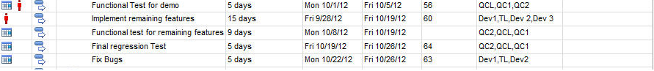

# DELIVERABLES

|  |  |  |  |  |
| --- | --- | --- | --- | --- |
| **No.** | **Deliverable** | **Date** | **Responsibility** | **Delivered to** |
|  | Test plan | Sept 21th, 2012 | Thuy Vu | Client |
|  | Test cases | Sept 28th , 2012 –Weekly | Thuy Vu | Client |
|  | Test result | Oct 26th, 2012 | Thuy Vu | Client |
|  | Final tested package | Oct 31th, 2012 | Thuy Vu | Client |

# SUSPENSION / EXIT CRITERIA

## Suspension Criteria

If any defects are found which seriously impact the test progress, the test team may choose to

Suspend testing. Criteria that will justify test suspension are:

* Hardware/software is not available at the times indicated in the project schedule.
* Source code contains one or more critical defects, which seriously prevents or limits testing progress.
* Assigned test resources are not available when needed by the test team.
* Main functions which are in the release note had not been properly met.

## Resumption Criteria

If testing is suspended, resumption will only occur when the problem(s) that caused the suspension has been resolved. When a critical defect is the cause of the suspension, the “FIX” must be verified by the test department before testing is resumed.

## Exit Criteria

Testing will be considered complete when the following conditions have been met:

1. All test cases in all areas have executed.
2. The outstanding bugs are less than the numbers of bugs which are agreed for entry UAT.

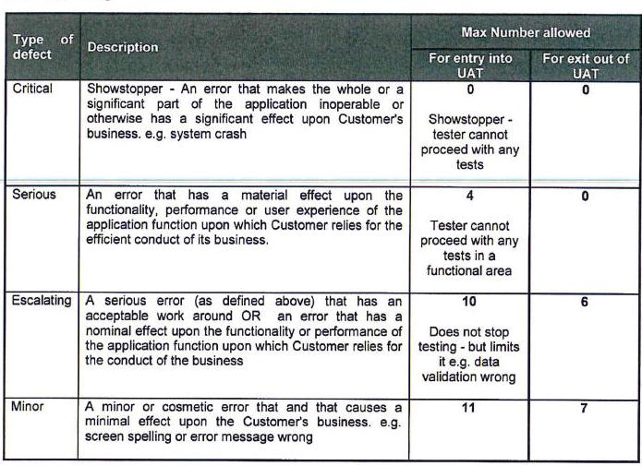

# REFERENCES AND RELATED DOCUMENTS

|  |  |  |  |
| --- | --- | --- | --- |
| **No.** | **Document** | **Comments** | **Version** |
| 1 | <Project Name>_ Project Charter v0_4 |  |  |
| 2 | <Project Name>_SRS v1.0 |  |  |